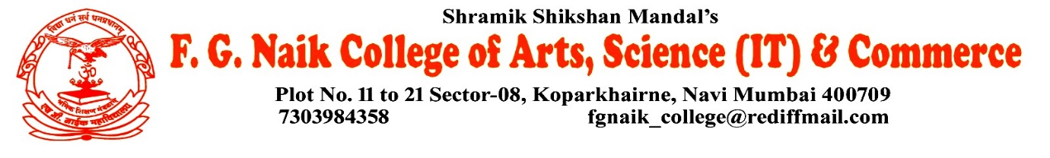

NSS UNIT
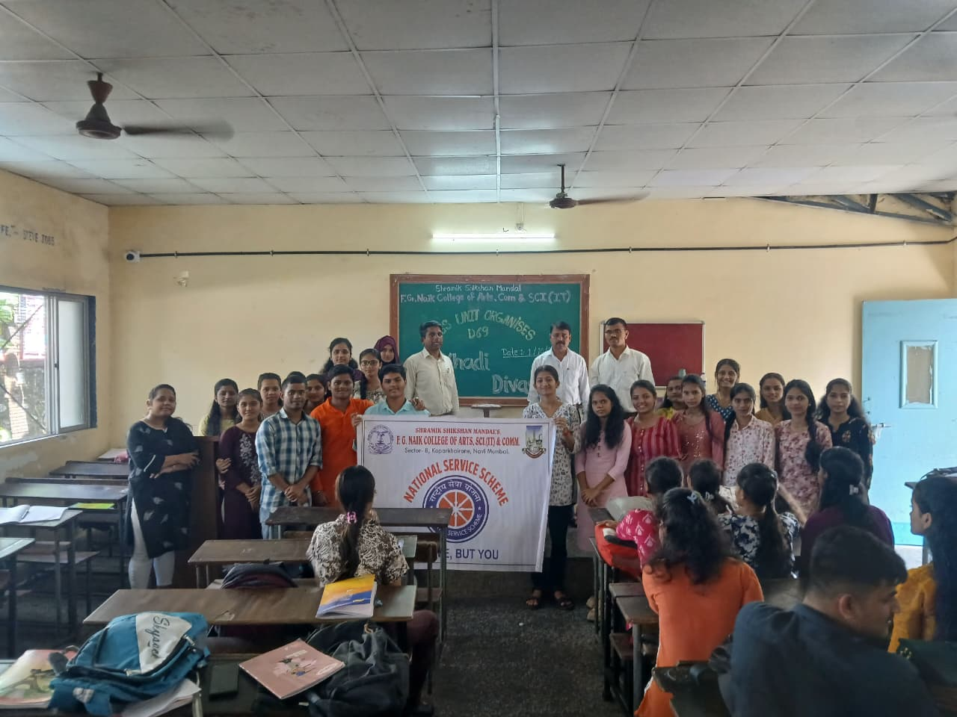
KHADI DIWAS CELEBRATION

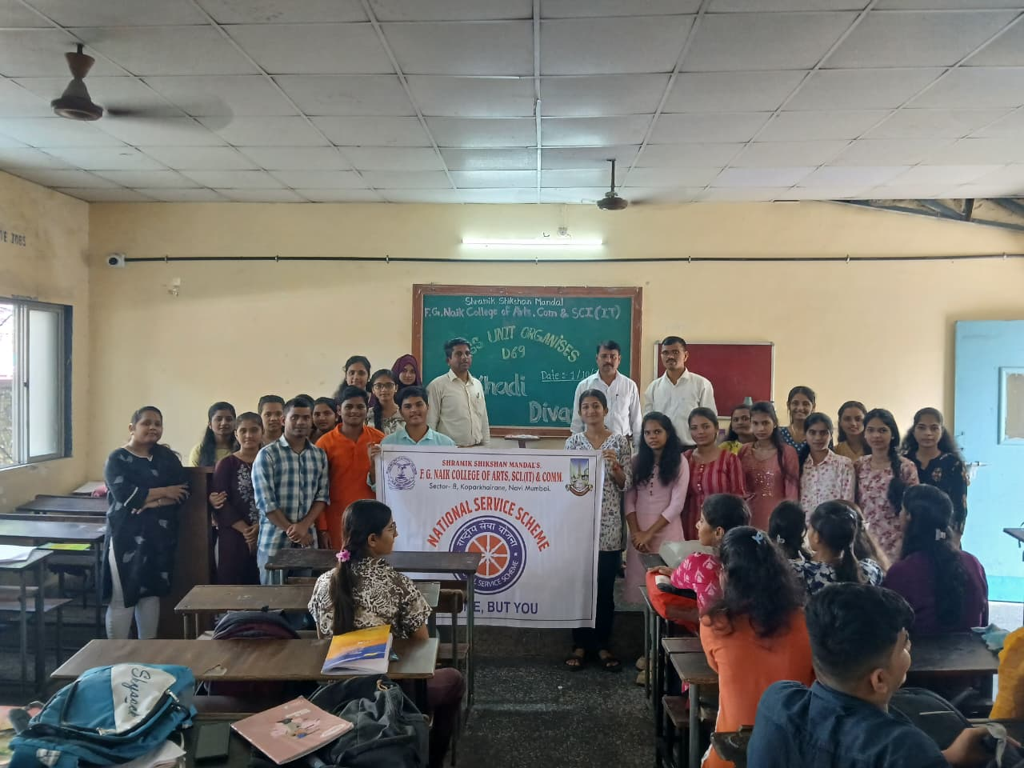
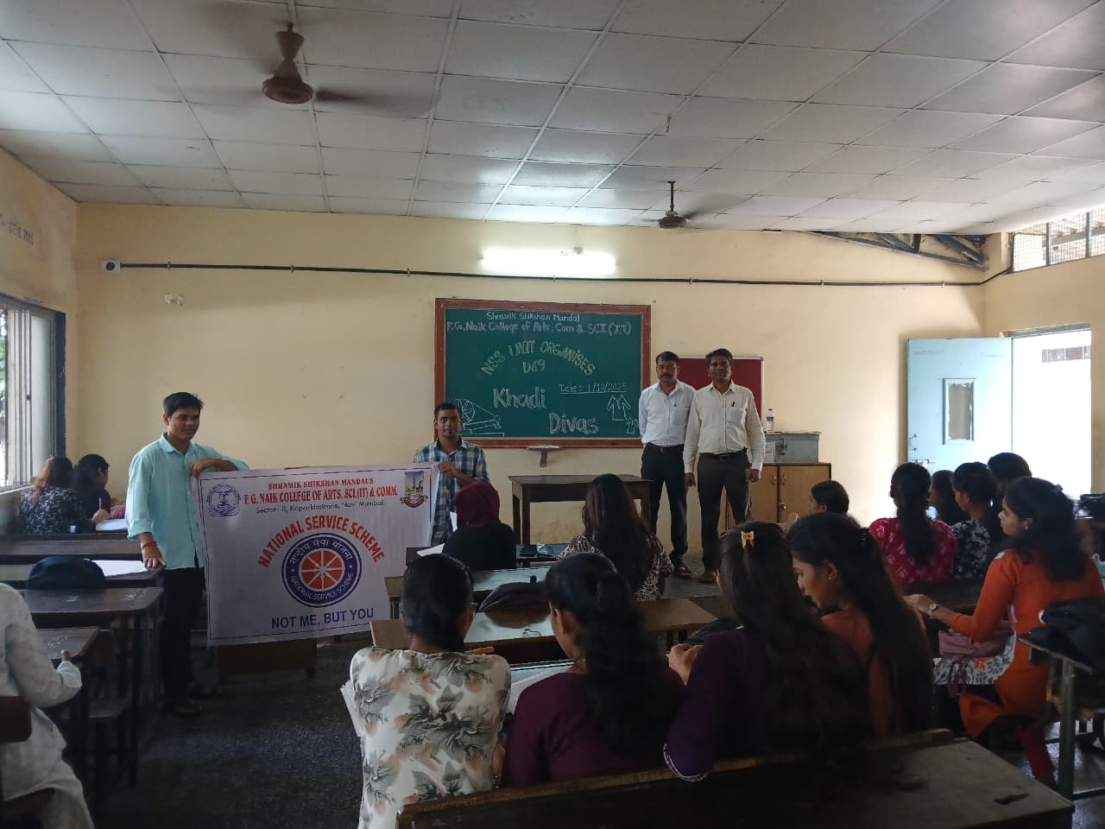

OBJECTIVE OF PROGRAM: To promote awareness about the importance of Khadi, encourage the use of indigenous products, and highlight the values of self-reliance, sustainability, and national pride.
DATE: 01/10/2025
LOCATION: F.G Naik College
PARTICIPATING STAFF: All the NSS volunteers, teaching and the non-teaching staff of the college.
NUMBER OF VOLUNTEERS PARTICIPATING: 24
The NSS Unit organized the Khadi Diwas Celebration to highlight the significance of Khadi as promoted by Mahatma Gandhi. Gandhiji adopted Khadi as a symbol of freedom, simplicity, and self-dependence during India’s freedom struggle. The program aimed to educate students about Gandhiji’s vision of Swadeshi and the role of Khadi in empowering rural artisans.
Through discussions and awareness activities, students were encouraged to follow Gandhiji’s ideals by adopting Khadi in their daily lives. The celebration inspired participants to respect Indian traditions and contribute towards building a self-reliant nation.
PROGRAM DETAILS: The program commenced with a formal welcome, setting a respectful and meaningful tone for the event.
The NSS Unit successfully conducted the Khadi Diwas Celebration, emphasizing Gandhiji’s message of self-reliance and the continued relevance of Khadi in modern India.

NSS IQAC
PROGRAM OFFICER CO-ORRDINATOR I/C PRINCIPAL

